Software Requirements Engineering Lab
Name: Muhammad Sufyan
Student ID: 16063
Class ID: 119005

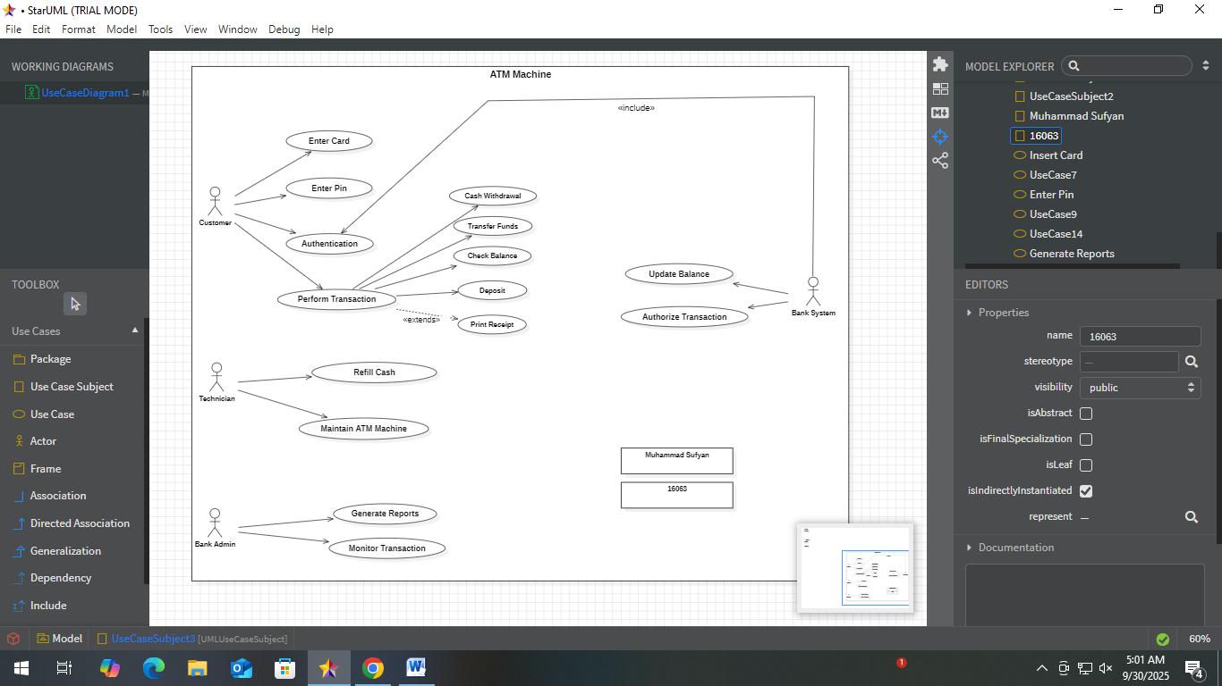
Summary:
Customer information is verified by the bank system, once data is authenticated then customer is able to perform transactions. When the ATM runs out of cash or requires maintenance then the Technician performs tasks relevant to it. The bank admin generates reports every month as well as monitors transactions taking place.

